CONTRACTOR
SCOPE OF WORK

xxxx Xxxxxxxx Drive
Marietta, GA 30008

Floor Plan Reconfiguration
- Configuration as illustrated below
- Add power outlets as necessary to accommodate for those removed
- Add light switches as necessary to accommodate for those removed

Pre-Rehab:
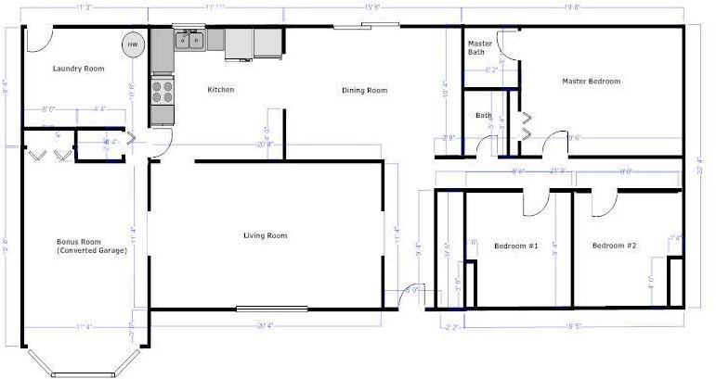

Post-Rehab:
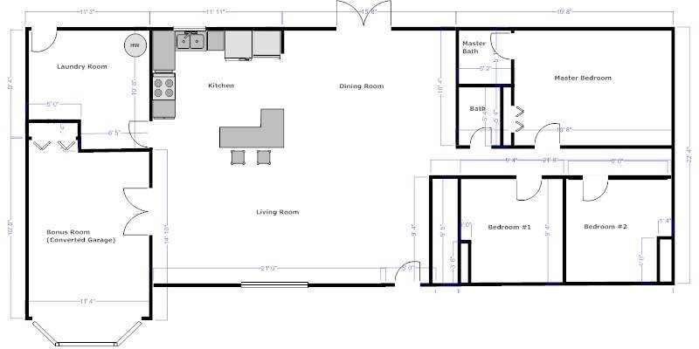
SYSTEMS
Plumbing
- Replace Hot Water Heater to code
- Water pressure is way too high (95 PSI). Investigate/remediate
Electrical
- Repair wire splices in attic (add electrical boxes or rewire)
- Put cover on breaker box
- Mis-wired circuits in Dining Room/Living Room (not all outlets are hot; some have no ground)
HVAC
- Add supply/return ducts in the bonus room (converted garage)
- Add supply/return ducts in the laundry room
- Repair/replace corroded furnace venting/duct work in attic and crawlspace
- Repair loose insulation in crawl space
- Repair points of air leakage in crawl space
- Add air supply registers and return grill in Laundry Room (depending on cost)
Other
- Repair door-bell

INTERIOR
General
- Patch all walls and trim in preparation for paint
- Replace all interior entry doors with new 6-panel doors and new door hardware
- Replace all interior closet doors with new slab doors and new door hardware
- Replace all vent covers where missing
- Fix/replace outlets/covers as necessary (ensure matching colors and styles)
- Fix/replace switches/switch-plate covers as necessary (ensure matching colors and styles)

Painting
- Paint entire interior with three color paint scheme (walls, trim, ceiling)

Kitchen
- Keep sink/faucet/disposal
- Replace all cabinets
- Replace countertops
- Tile backsplash behind counters
- Replace all appliances (stove, microwave, fridge, dishwasher)
- Add L-Shaped island between kitchen and living room (w/cabinets and countertops)
- Replace light fixture with 4 cans recessed lighting
- Replace aluminum window with new vinyl window
- Replace vinyl flooring with ceramic tile
Dining Room
- Remove sliding glass door and replace with French Doors leading onto back deck
- Remove faux beams on ceiling
- Replace vinyl flooring with laminate hardwood
- Remove paneling and sheetrock room
- Replace light/fan combination with chandelier
Entryway
- Replace front entry door
- Replace vinyl flooring with laminate hardwood
- Repair light switches in entryway
- Replace light fixture with 1 can of recessed lighting
Living Room
- Lay laminate hardware floors
- Add 6 cans of recessed lighting
Converted Garage/Bonus Room
- Level floor (add new subflooring?)
- Add additional HVAC supply/return vents for better temperature regulation
- Remove drop ceiling
- Remove paneling
- Sheetrock entire room
- Lay carpet
- Frame and sheetrock entryway leading to kitchen/laundry
- Replace archway entry from living room with French Doors

Laundry Room
- Fix/replace subfloor
- Sheetrock entire room
- Add HVAC supply/return vents for better temperature regulation
- Properly case and replace door to outside, including sill
- Lay vinyl flooring
- Replace light fixture
- Install washer/dryer
Hallway
- Lay carpet
- Replace light fixture
- Cover doorbell transformer
Hallway Bathroom
- Replace floor with ceramic tile (including small closet)
- Add shelving in small closet
- Replace toilet
- Replace vanity/sink
- Replace mirror
- Replace light fixture
- Clean tub
- Add shower curtain bar
Master Bathroom
- Keep toilet
- Replace aluminum window with new vinyl window
- Remediate mold in shower (may need to replace sheetrock)
- Caulk around crown molding to hide cracks (or replace crown molding)
- Replace floor with ceramic tile
- Replace fiberglass shower base
- Use same ceramic tile from floor on shower walls
- Replace vanity/sink
- Replace mirror
- Replace light fixture
- Replace shower frame and door
- Replace shower water knobs/valves

Bedroom #1
- Lay carpet
- Replace light/fan fixture
- Replace hardware on double closet doors
Bedroom #2
- Lay carpet
- Replace aluminum window with new vinyl window
- Replace light/fan fixture
Master Bedroom
- Lay carpet
- Replace light/fan fixture
- Replace both aluminum windows with new vinyl windows
- Replace hardware on double closet doors

EXTERIOR
Paint
- Paint entire non-brick exterior (including trim/shutters)
- Paint front porch concrete
- Pressure-wash brick to try to remove existing paint
Roof
- Repair damaged gutters
- Fix damaged/missing downspout sections
- Clean gutters
- Repair soffits/fascia board/trim around entire exterior as necessary
Front Steps/Deck
- Pressure wash concrete
Back Deck
- Remove existing concrete deck for better drainage away from house
- Build deck off French Doors leading from Dining Room
- Deck should be the size of the concrete patio
- Steps leading off deck to back-yard
Landscaping
- Grade land/dirt away from house where necessary to ensure proper grading
- Demo shed in back yard
- Remove existing foundation (or whatever is there) next to shed to allow grass to grow
- Trim all bushes
- Trim lower branches off front trees (to display the house)
- Clean-up the backyard
Other
- Fix flashing between brick/wood under front windows (replace with sealant/caulking)

